Curriculum Vitae
Dr. Brian Lang

Professor
Department of Religion and Philosophy
Unruh School of Leadership
University of Jamestown

Education
Ph.D. Philosophy (2004), University of Missouri, Columbia, Missouri.
M.A., Philosophy (2000), University of Missouri, Columbia, Missouri.
B.Th., (1998), Ozark Christian College, Joplin, Missouri.

Philosophical Affiliation
Greek Cynicism

Honors and Awards
Olive Garden – Certified Trainer, 1997
Donald K. Anderson Graduate Student Teaching Award, Graduate School, University of
Missouri-Columbia, 2001
Participant in “Teaching About Islam and Middle Eastern Culture”, American Center for
Oriental Research, Amman, Jordan, January 2010, sponsored by the Council of Independent Colleges (CIC) & the Council of American Overseas Research Centers (CAORC) Carengie Corporation of New York Grant 2011
Professor of the Year, University of Jamestown 2011
Thomas W. Selleck Professor of Alchemy, University of Jamestown 2020
Emperor of Ethics, Jamestown Regional Medical Center, 2020
Faculty Mentor – Dilar Dirik, Chris Kramlich, Robert Hanna

Courses
Phil 252 – Ethics
Phil 303 – Classical Philosophy
Phil 304 – Philosophy of Art
Phil 390 – Feminism
Soothsaying Tekne Certifications
Heira, Sphagia, Augury, Cledomancy, Casting Lots, Empyromancy

Academic Presentations & Papers
"A Simple Defense of the Ontological Argument," Auslegung, Spring/Summer 2003, Vol.
24, No. 2.
"When Religion Motivates Politics: A Reply to Audi," Central States Region SBL, April
2003
"When Religion Motivates Politics: A Reply to Audi," Proceedings of the Central States
SBL / ASOR 1 (2003)

Dissertation Abstract - 'Cartesian Simplicity'
Descartes' commitment to the doctrine of Divine Simplicity—the view that God has no metaphysical parts—is both defensible and useful in resolving a broad range of perennially troublesome Cartesian claims. These include the alleged Cartesian circularity and a classic reductio often wielded against the ontological argument. In addition, Descartes’ insight into the nature of perfection fuels constructive work within the “perfect being theology” branch of contemporary analytic philosophy of religion.

PORTRAITURE
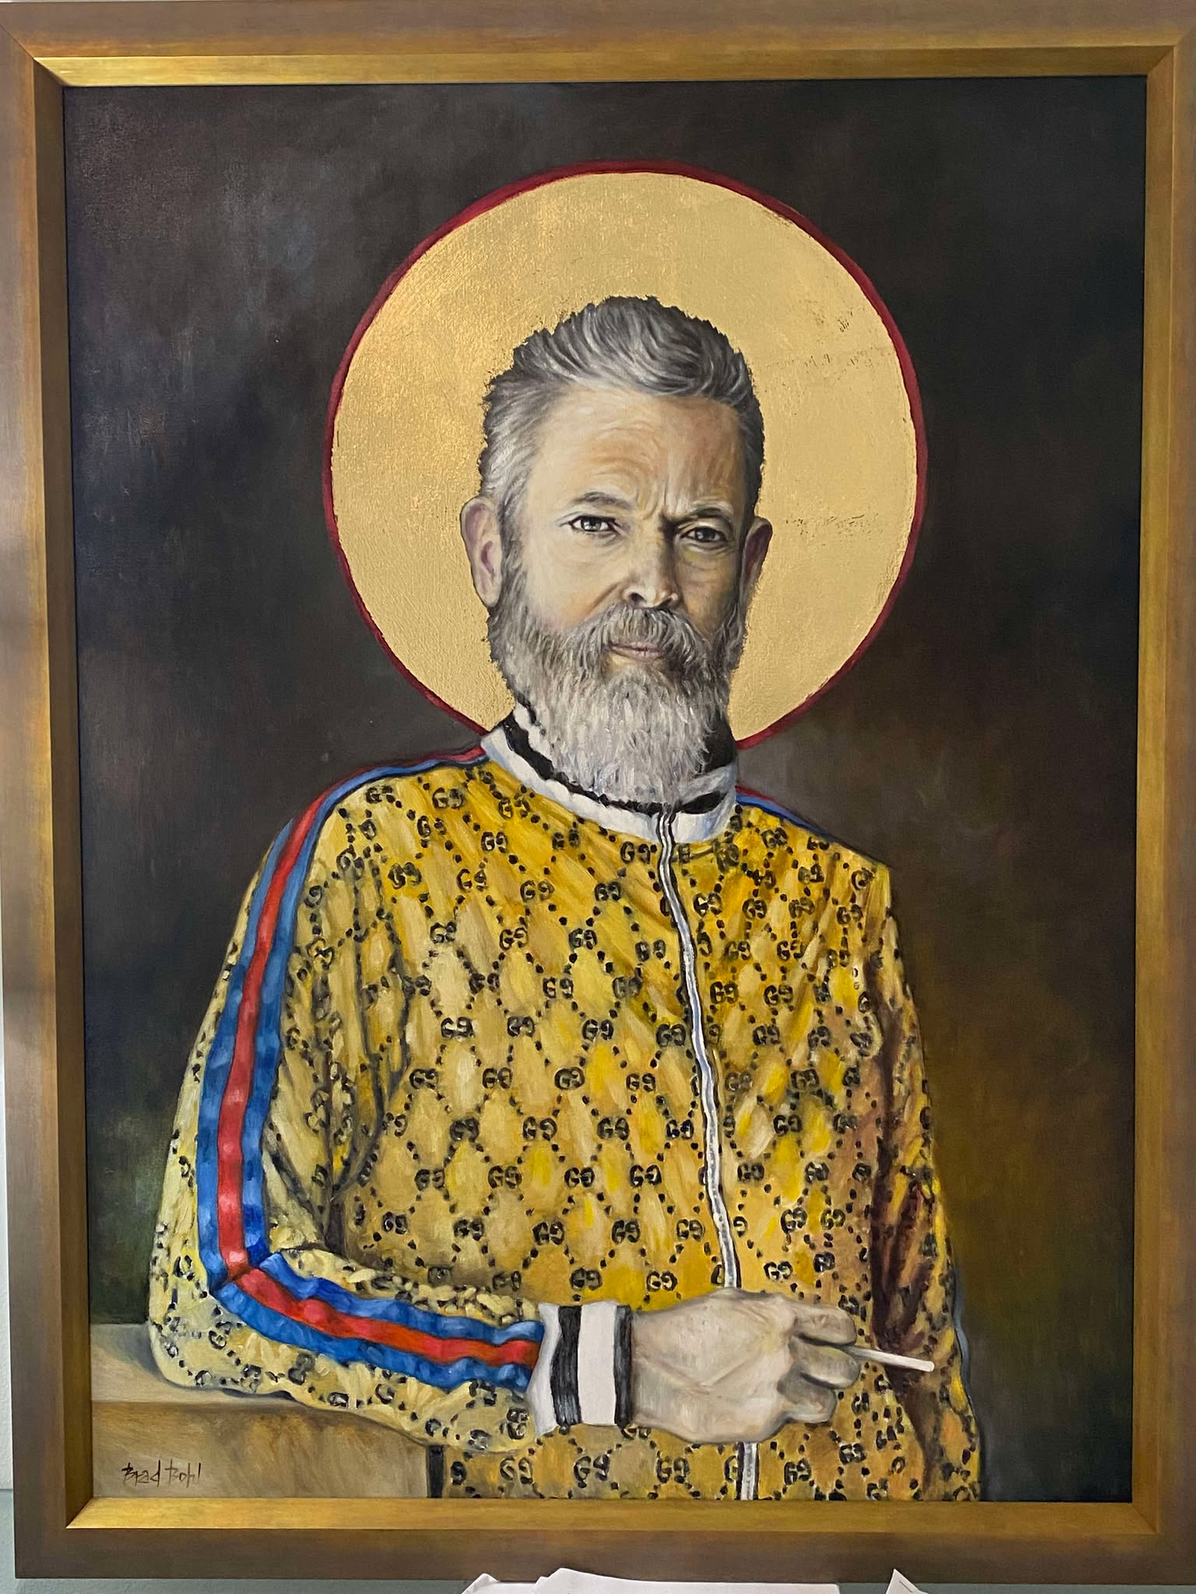

‘Asinus Aureas’ – Brad Bohl, ‘25
REFERENCES
Dr. Joseph Bien
Dr. John Kultgen
Dr. Donald Sievert
https://philosophy.missouri.edu/people/in-memoriam

